Parth Babbar

Branch network management

**Introduction:**

Effective branch network management is critical in industries such as banking, retail, and healthcare, directly affecting customer service, operational efficiency, and corporate profitability. This document delves into essential tactics, statistical findings, and a case study demonstrating effective implementation. It focuses on making strategic decisions about branch placement, design, and operations in order to provide effective customer service while minimising costs and resources.

**Importance of Branch Network Management:**

1. **Customer Access:** Allows consumers to easily access financial services.
2. **Cost Efficiency:** Balances the expenses of branch maintenance against the advantages of client accessibility.
3. **Market Presence:** Improves the bank's brand and market penetration.

**Key Components:**

1. **Network Design and Optimization:** Branch location strategy entails analysing demographic data, consumer density, and rival locations to strategically position branches for optimal efficacy. Furthermore, optimising branch architecture and design is vital to guaranteeing smooth client flow, service efficiency, and keeping interior security requirements. These components are critical for improving the customer experience and operational performance in branch networks across several sectors.
2. **Technology Integration:** Digital transformation entails integrating digital platforms such as online banking, smartphone apps, and digital kiosks to reduce foot traffic and improve customer experience. Furthermore, it is critical to provide a strong IT infrastructure that maintains seamless communication and high data security requirements across all branches. These initiatives are critical to modernising operations and fulfilling the changing expectations of customers in today's digital age.
3. **Customer Experience:** Personalised service entails using customer data analytics to tailor services and offers to individual tastes, hence improving customer happiness and loyalty. Furthermore, using an omni-channel strategy guarantees a consistent experience across numerous channels, including as branches, online platforms, and mobile applications, successfully catering to a wide range of client wants and preferences. These tactics not only promote client involvement, but also boost overall operational efficiency and market competitiveness.
4. **Risk Management and Compliance:** Implementing strict security standards is critical for protecting client data and assets in branch operations. Furthermore, ensuring regulatory compliance with industry norms and laws is critical for all aspects of branch administration. These measures promote trust, security, and legal compliance, protecting both consumer interests and organisational integrity.  
   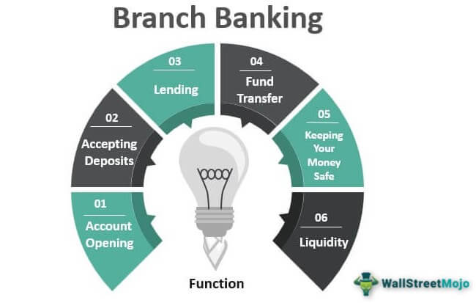

**Trends:**

1. **Digital Transformation:** As people rely more on digital banking, physical branches become less necessary.
2. **Branch Optimisation:** Close underperforming branches and concentrate on high-traffic regions.
3. **Customer-Centric Design:** Redesigning branches to provide advisory services and digital banking support.

**Strategies:**

1. **Data-Driven Decisions:** Customer analytics utilises customer data to identify the optimal branch sites, whereas market analysis evaluates demographics and competition to make educated decisions that maximise growth and customer happiness.
2. **Flexible Branch Model:** Micro-branches are small, technology-driven hubs that specialise in advisory services, whereas flagship branches are large centres that offer a wide variety of services and provide an exceptional client experience.
3. **Enhanced Digital Integration:** Self-service kiosks and mobile banking applications, as well as digital signage, have been used to improve service efficiency and client convenience, while virtual banking services for distant advice are also available via video conferencing.

**Statistics:**

1. As of 2023, the number of bank branches in the United States has decreased by 2.2%, indicating the transition to digital banking.  
   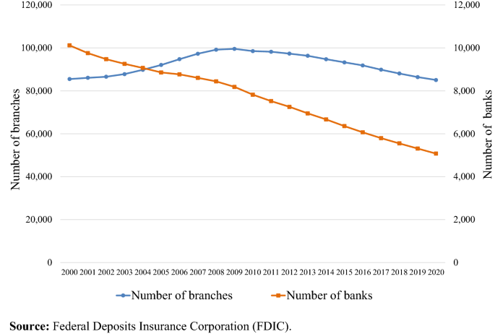
2. Digital banking use has surged by 15% in the last three years, affecting banks' branch practices.

**Conclusion:**

Effective branch network management necessitates a comprehensive strategy that incorporates technology, operational efficiency, and customer-focused tactics. Organisations that use data-driven insights and embrace digital transformation can adapt to changing customer preferences and market dynamics, ensuring regulatory compliance and increasing operational resilience while significantly improving service quality, cost efficiency, and customer satisfaction.